Assignments:
- Use git tag to create and manage tags.
Ans: In Git, a tag is a reference to a specific commit in a repository. Tags are used to mark important points in the history of a project, such as releases or versions.

The git tag command is used to manage tags in a Git repository. Here are some common uses of the command:

- git tag → lists all the tags in the repository.
- git tag -a <tag_name> -m "<tag_message>" → creates a new tag with a message.
- git tag -d <tag_name> → deletes a tag.
- git push origin --tags → pushes all tags to the remote repository.
- git checkout <tag_name> → checks out the code at the specified tag. Means HEAD is changed to that particular tag commit.
- git show <tag_name> → See Tag Details
- git restore --source=<tag_name> <file-name> → To restore a file from that tag
- git restore --source=<tag_name> . → Restore Multiple Files

- Compare git revert vs git reset vs git restore.
Ans:
git revert:
- Reverts a specific commit, creating a new commit that reverses the changes.
- Preserves the original commit history.
- Useful for undoing changes while maintaining a clean history.
Example: git revert <commit_hash>

git reset:
- Resets the current branch to a specific commit, discarding all changes after that commit.
- Options:
- --soft: Resets the branch pointer, but keeps changes in the staging area.
- --hard: Resets the branch pointer and discards all changes.
- Alters the commit history.
- Useful for undoing changes and starting fresh from a specific point.
Example: git reset <commit_hash> (or --soft or --hard)

git restore:
- Restores files or directories to a specific commit or state.
- Can restore files from a specific commit, index, or the current working tree.
- Does not create a new commit.
- Useful for recovering files or undoing changes to specific files.

- Create a pull request, add collaborators, and get reviews.
Ans:
Login to Github >> Create a repo >> Go to settings >> collaborators >> Click on Add people >> Add the username or email address of the collaborator we are inviting: NagarajKamath >> The collaborator needs to accept the invitation from their end.

Now I created a branch named: test and made changes in the README.md file. Then we will find a compare and pull request or else create a pull request and add a reviewer and also add an assignee (who has authority to merge the pull request).
The collaborator will check the changes and approve requests by clicking on File changed >> submit review. If the reviewer approves the changes, then we can merge the branch. If the reviewer asks to make some changes, then we need to update the changes and send for approval again. After getting approval, we will merge the branch.

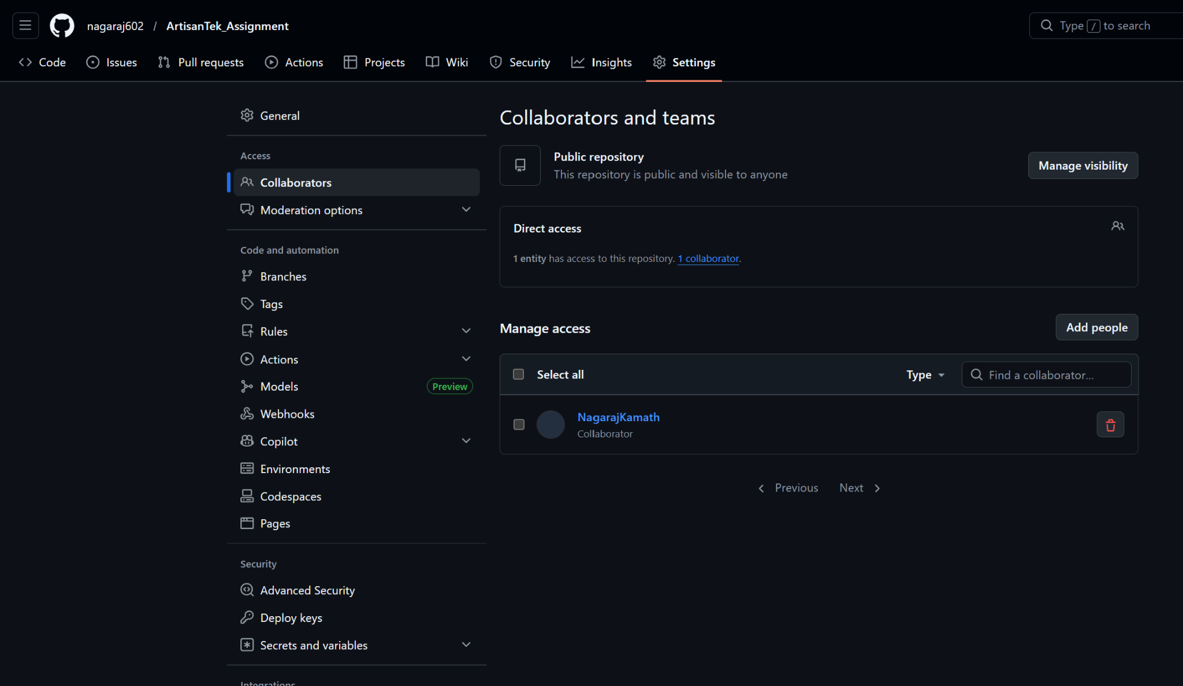

Screenshot from collaborator account, after accessing the invitation: 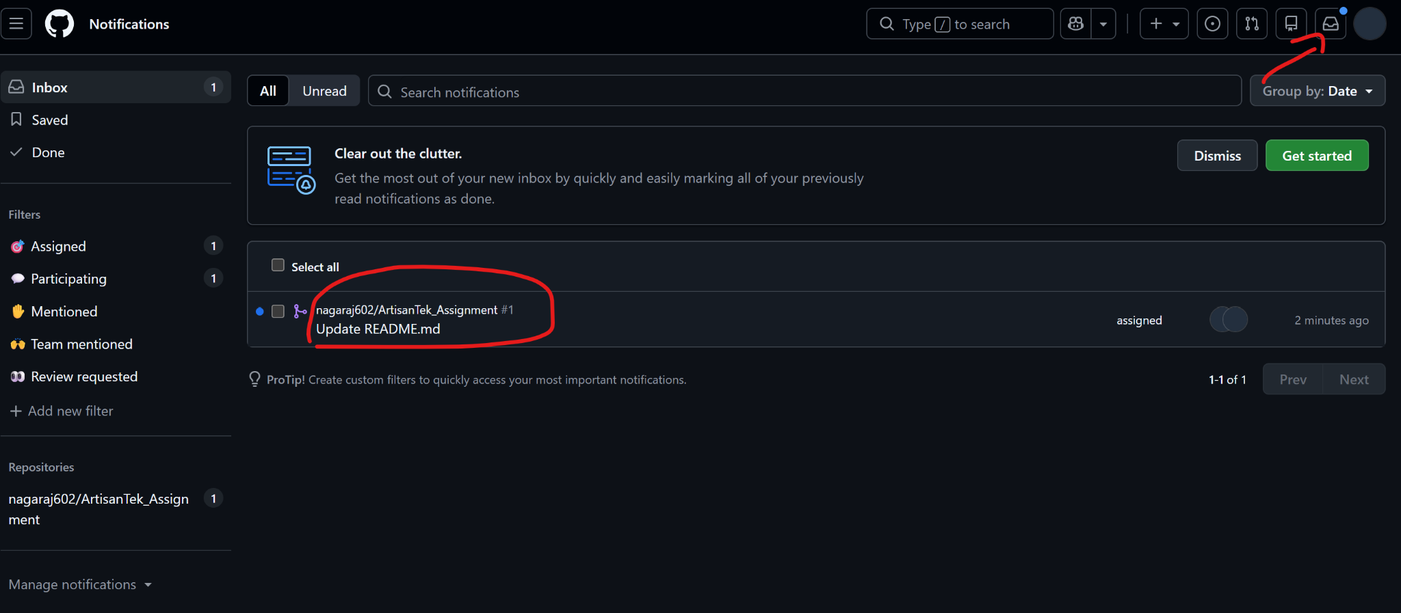

Screenshot from reviewer end showing the option of submit review:
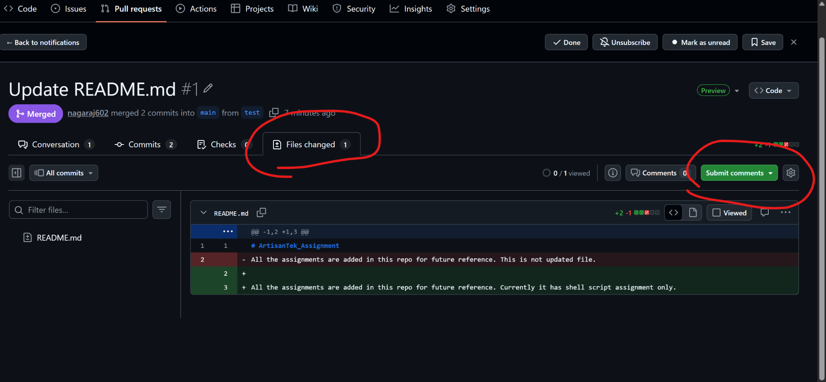

Screenshot from the owner end who got approval from reviewer and merged the pull request:
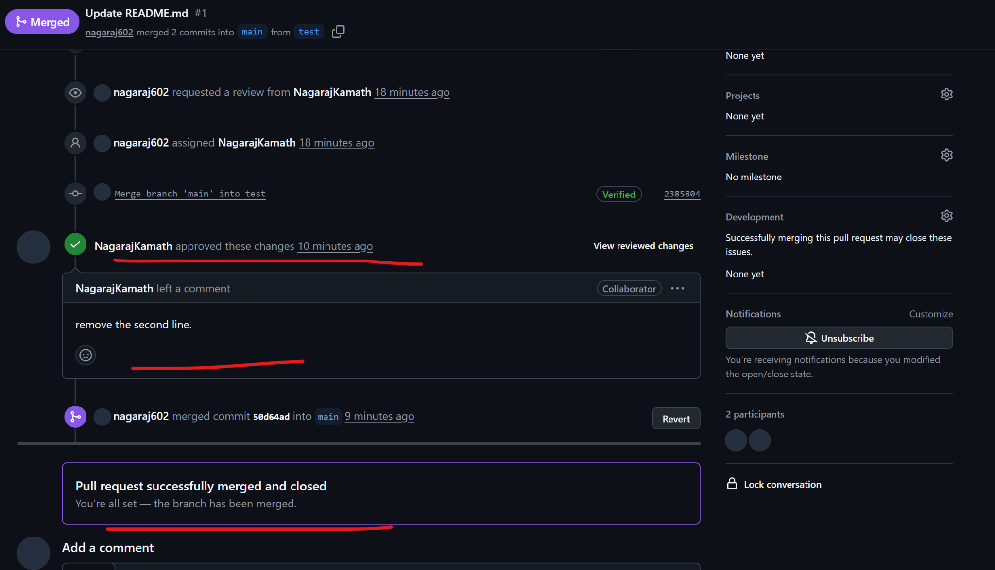

- Understand GitHub Actions for CI/CD. --> this can be ignored for now

- Task1: Branching & Merging
- Initialize a new Git repo called git_practice.
- Create a new branch feature/login.
- Add a file [login.sh](http://login.sh/) and commit changes.
- Switch to main, create another file [readme.md](http://readme.md/), and commit.
- Merge feature/login into main.
- Resolve any merge conflicts if they occur.
- Push all branches to GitHub.
Ans:
→ mkdir git_practice
→ cd git_practice
→ git init
→ touch README.md
→ git add .
→ git commit -m "Added README.md file"
→ git branch
→ git checkout -b login
→ touch login.sh
→ git add .
→ git commit -m "Added login.sh file in login branch"
→ git switch main
→ touch readme.md
→ vi README.md
Added one line in README.md
→ git add .
→ git commit -m "Added a line README.md"
→ git switch login
→ vi README.md
Added different text in same line
→ git add .
→ git commit -m "Added different line in README.md file"
→ git switch main
→ git merge login

o/p: Auto-merging README.md
CONFLICT (content): Merge conflict in README.md
Automatic merge failed; fix conflicts and then commit the result.
→ vi README.md
Resolved the merge conflict.
→ git add .
→ git commit -m "Resolved merge conflicts"
Now we push to remote repo by linking remote repo URL to local repo. First create an empty repo without README.md file in github.com.
→ git remote add origin https://github.com/nagaraj602/git_practice.git
→ git push --set-upstream origin main
→ git push --set-upstream origin login
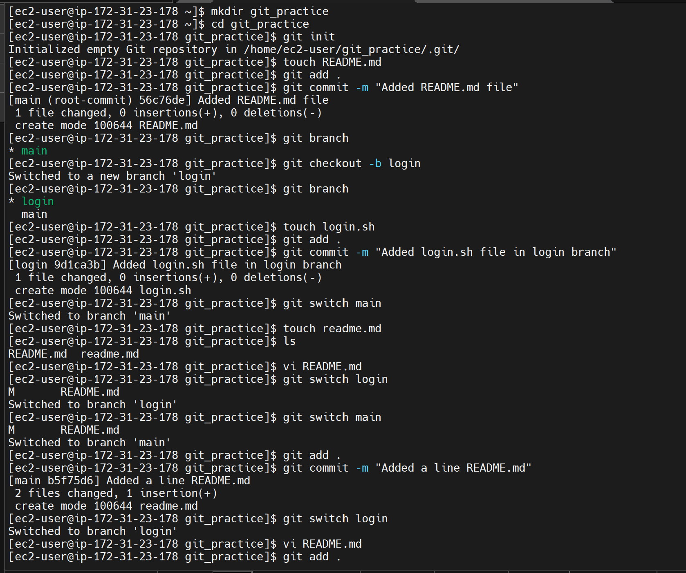

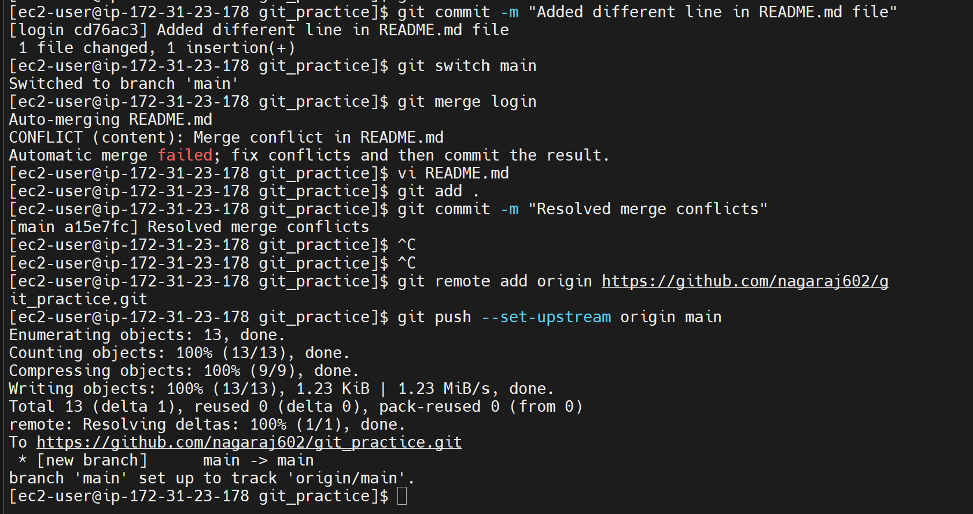

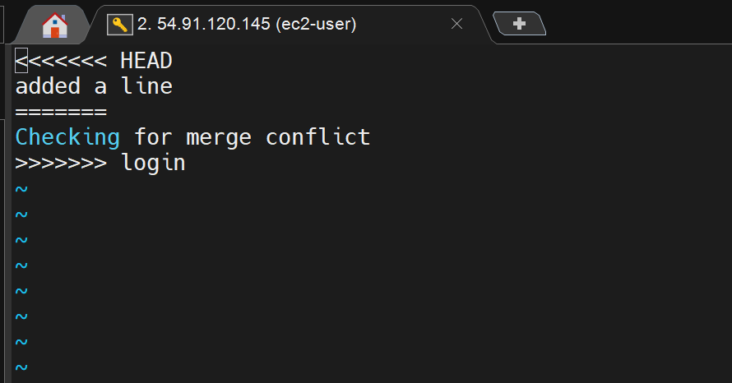

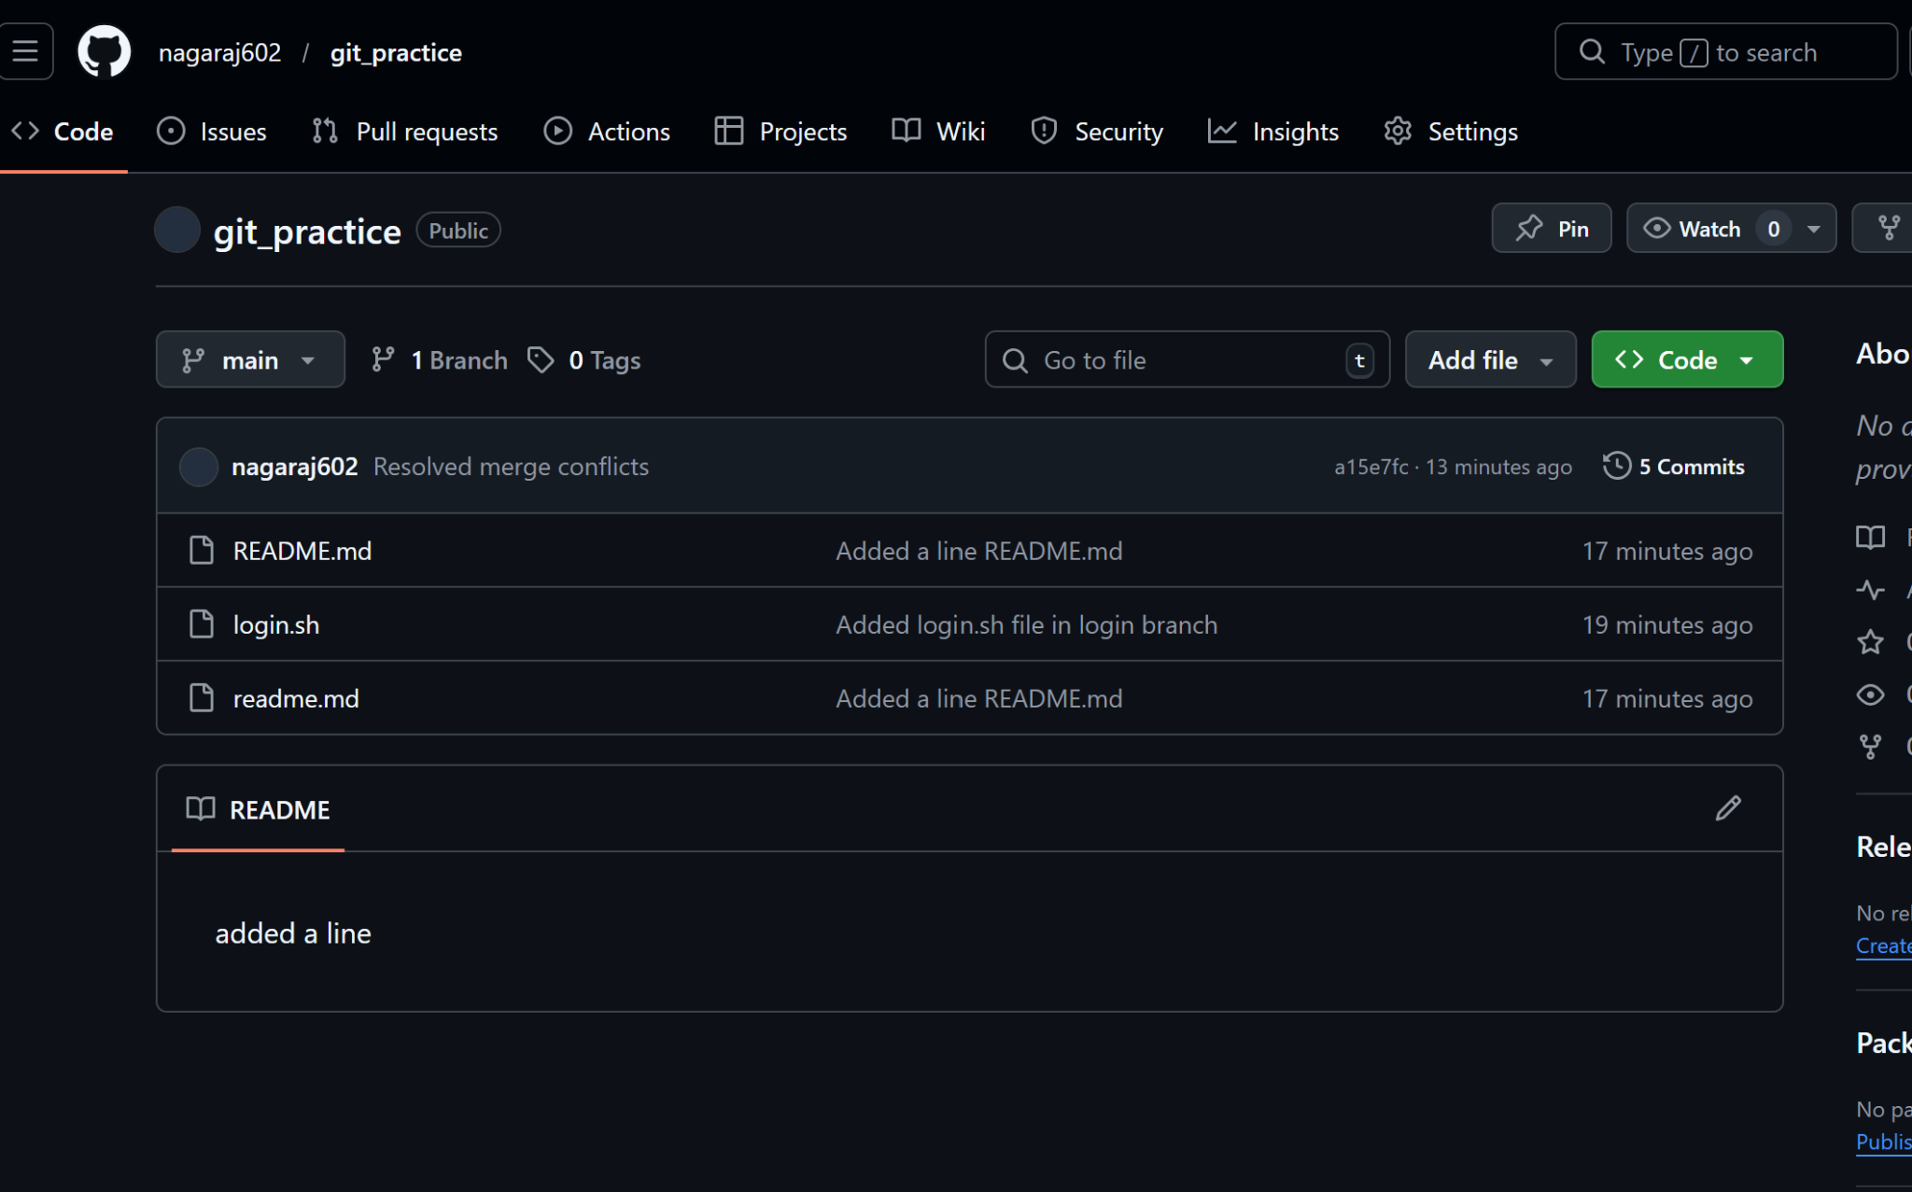
- Task2: Revert & Reset
- Create a Git repo git_reset_revert_demo.
- Add 3 commits by modifying a file demo.txt.
- Use git log to identify commit hashes.
- Use git revert to undo the second commit without removing history.
- Then use git reset --hard to go back to the first commit.
- Push the final repo to GitHub and share a screenshot of git log --oneline.
Ans:
→ mkdir git_reset_revert_demo;cd git_reset_revert_demo
→ git init
→ touch demo.txt
→ git add .
→ git commit -m "Created file demo.txt"

→ vi demo.txt
#Added first in it
→ git add .
→ git commit -m "Added first line to the file demo.txt"

→ vi demo.txt
#Added second line in it
→ git add .
→ git commit -m "Added second line to the file demo.txt"

→ git log
→ git log --oneline
o/p:
ed7551d (HEAD -> main) Added second line to the file demo.txt
1ca36cd Added first line to the file demo.txt
583e0b2 Created file demo.txt

Now we revert second commit:
→ git revert 1ca36cd
Auto-merging demo.txt
CONFLICT (content): Merge conflict in demo.txt
error: could not revert 1ca36cd... Added first line to the file demo.txt
hint: After resolving the conflicts, mark them with
hint: "git add/rm <pathspec>", then run
hint: "git revert --continue".
hint: You can instead skip this commit with "git revert --skip".
hint: To abort and get back to the state before "git revert",
hint: run "git revert --abort".
hint: Disable this message with "git config advice.mergeConflict false"

→ cat demo.txt
<<<<<<< HEAD
First line
Second line
=======
>>>>>>> parent of 1ca36cd (Added first line to the file demo.txt)

This means, you tried to revert the changes to the second commit, meaning, removing the 2nd commit "First line" will cause issues for your 3rd commit, as you made changes in the same file. Since 3rd commit depends on 2nd commit, git cannot revert it. We need to resolve conflicts manually. That is we need to remove "First line" and keep only "Second line" in demo.txt

→ vi demo.txt
After making changes in the file, it looks like this:
[ec2-user@ip-172-31-23-178 git_reset_revert_demo]$ cat demo.txt
Second line

Now add the file to the staging area again.
→ git add .

Now continue the revert
→ git revert --continue

Go to insert mode and add the line as conflict resolved

:wq

Then the output shown on terminal will be:
[ec2-user@ip-172-31-23-178 git_reset_revert_demo]$ git revert --continue
[main 332e277] Revert "Added first line to the file demo.txt"
1 file changed, 1 deletion(-)

When we check the git log again, it shows new revert commit, by keeping commit history
→ git log --oneline

332e277 (HEAD -> main) Revert "Added first line to the file demo.txt"
ed7551d Added second line to the file demo.txt
1ca36cd Added first line to the file demo.txt
583e0b2 Created file demo.txt

Now git reset --hard to go back to the first commit:
→ git reset --hard 583e0b2

[ec2-user@ip-172-31-23-178 git_reset_revert_demo]$ git reset --hard 583e0b2
HEAD is now at 583e0b2 Created file demo.txt

→ git log –oneline

[ec2-user@ip-172-31-23-178 git_reset_revert_demo]$ git log --oneline
583e0b2 (HEAD -> main) Created file demo.txt

→ git remote add origin https://github.com/nagaraj602/git_reset_revert_demo.git
→ git push --set-upstream origin main

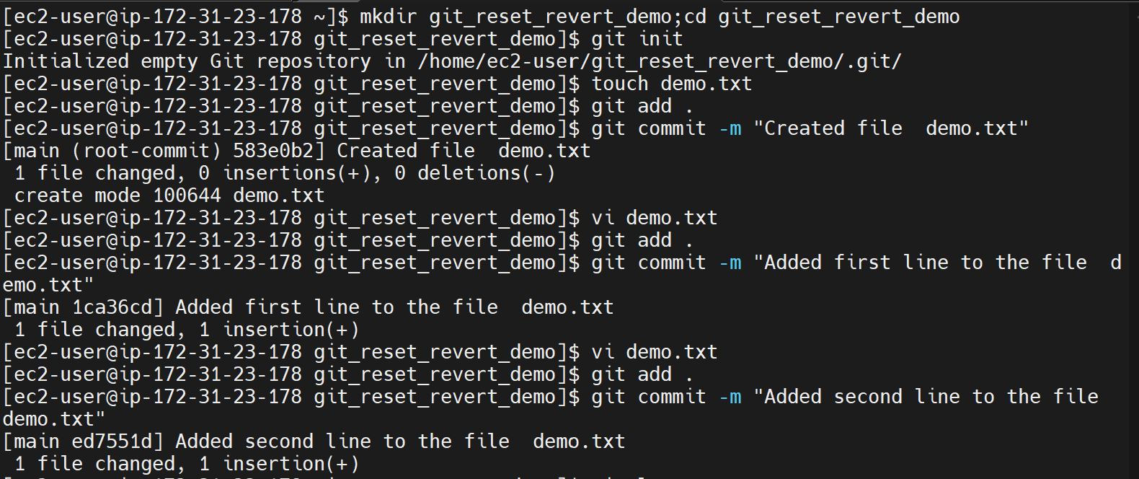

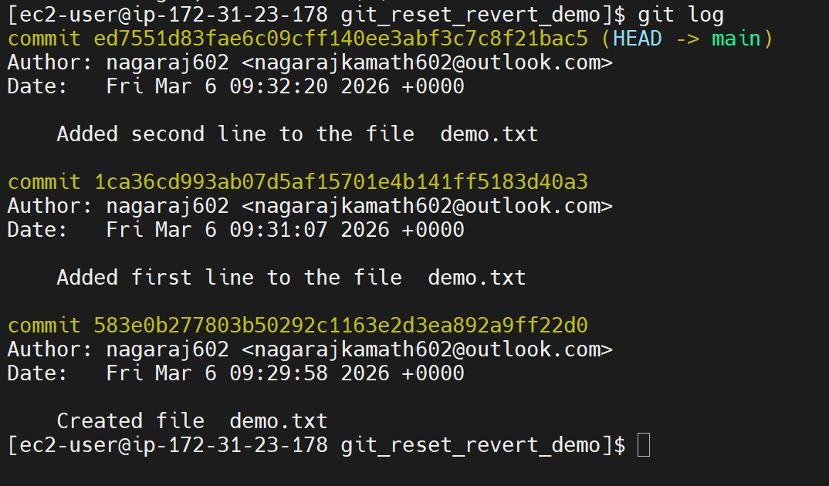
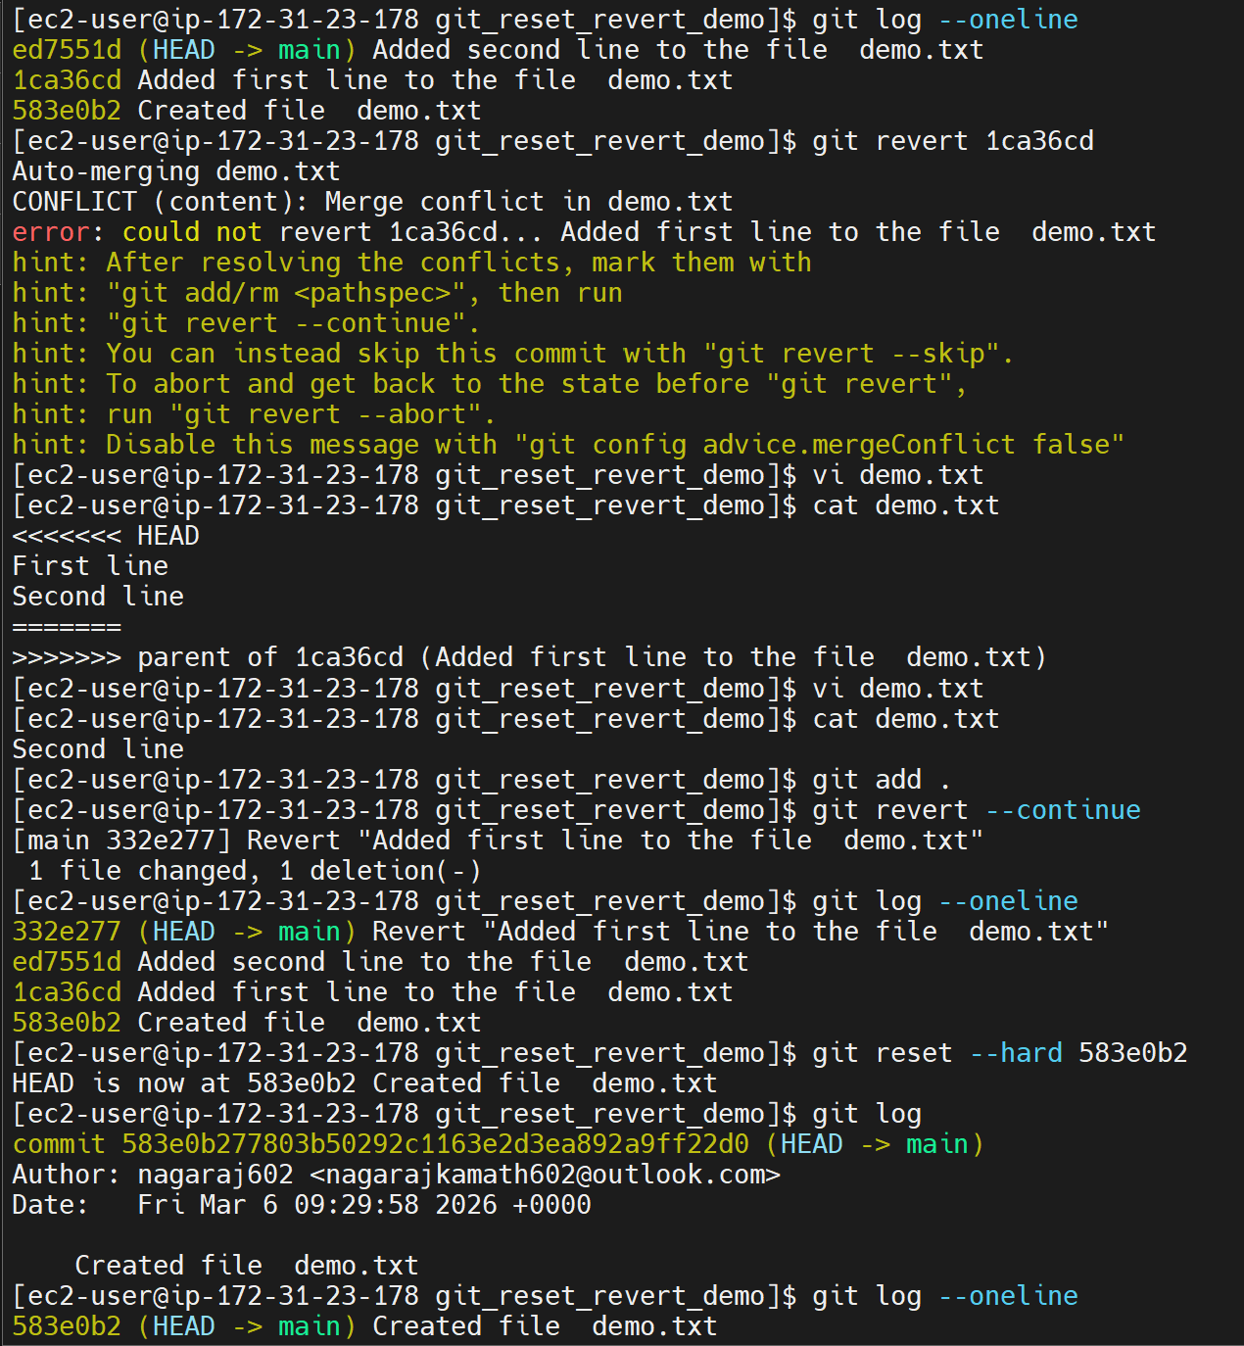

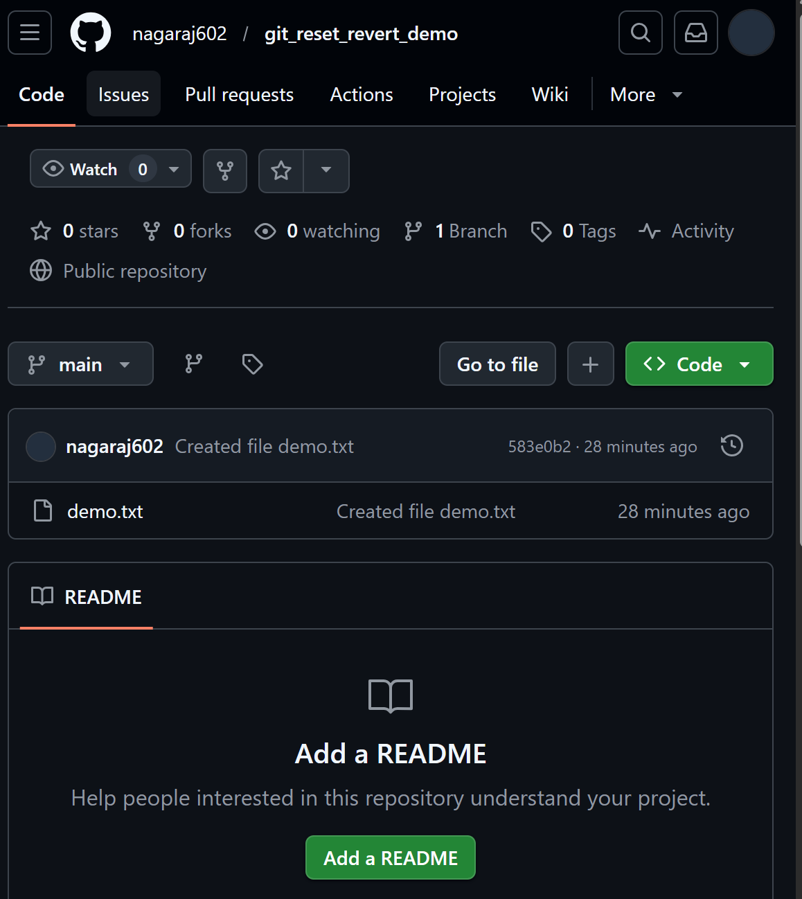

- Task3: Git Stash Scenario
- Create a repo stash_practice.
- Modify two files and don’t commit them.
- Run git stash to temporarily save your work.
- Switch to a new branch bugfix and make a new commit.
- Return to main and apply your stash using git stash apply.
- Push final code and share output of git stash list.
Ans:
→ mkdir stash_practice
→ cd stash_practice
→ git init
→ touch stash.txt practice.txt
→ echo "Hello Stash" > stash.txt
→ echo "Hello Practice" > practice.txt
→ git add .
→ git commit -m "Initial commit"
→ echo "New change in stash file" >> stash.txt
→ echo "New change in practice file" >> practice.txt
→ git status
[ec2-user@ip-172-31-23-178 stash_practice]$ git status
On branch main
Changes not staged for commit:
(use "git add <file>..." to update what will be committed)
(use "git restore <file>..." to discard changes in working directory)
modified: practice.txt
modified: stash.txt

no changes added to commit (use "git add" and/or "git commit -a")

→ git stash
[ec2-user@ip-172-31-23-178 stash_practice]$ git stash
Saved working directory and index state WIP on main: 5246f33 Initial commit

When we check git status again, working directory will be clean
→ git status
[ec2-user@ip-172-31-23-178 stash_practice]$ git status
On branch main
nothing to commit, working tree clean

→ git checkout -b bugfix
→ echo "Bugfix work" > bugfix.txt
→ git add .
→ git checkout main
→ git stash apply

[ec2-user@ip-172-31-23-178 stash_practice]$ git stash apply
On branch main
Changes not staged for commit:
(use "git add <file>..." to update what will be committed)
(use "git restore <file>..." to discard changes in working directory)
modified: practice.txt
modified: stash.txt

no changes added to commit (use "git add" and/or "git commit -a")

→ git add .
→ git commit -m "Applied stash changes"
→ git remote add origin https://github.com/nagaraj602/stash_practice.git
→ git push --set-upstream origin main
→ git push --set-upstream origin bugfix

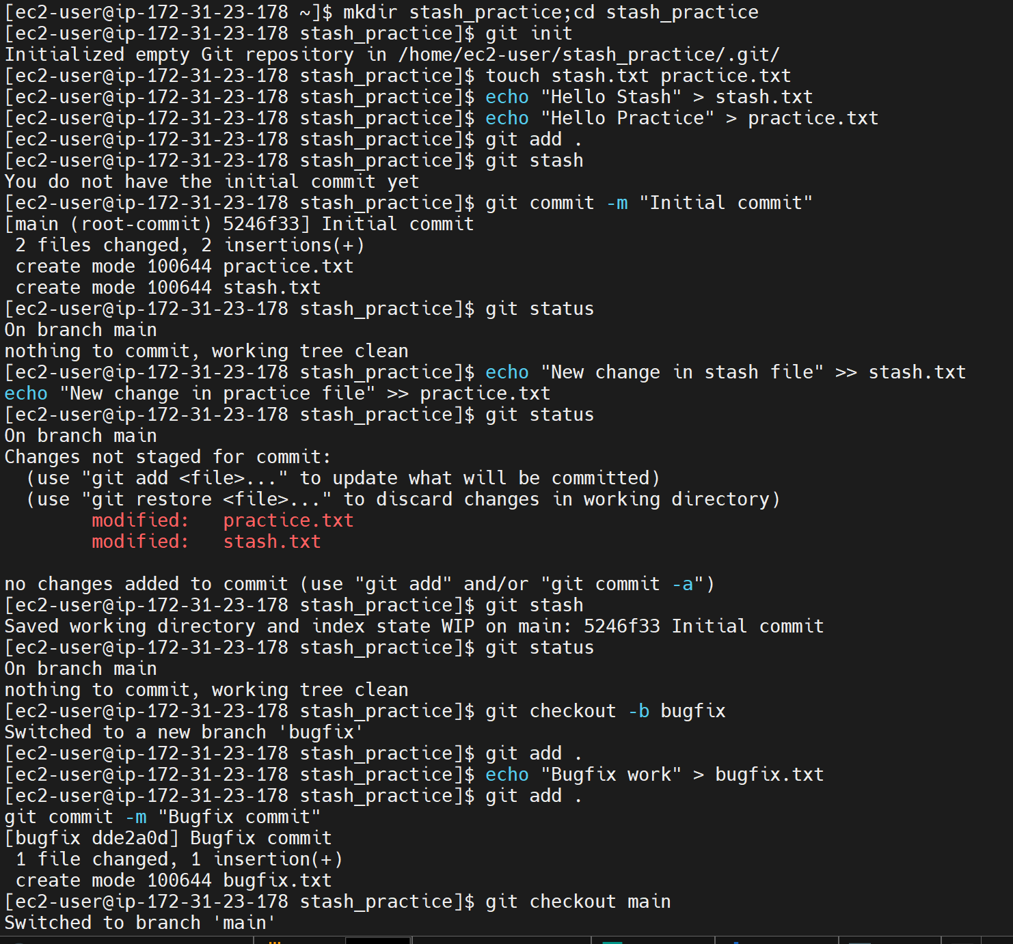

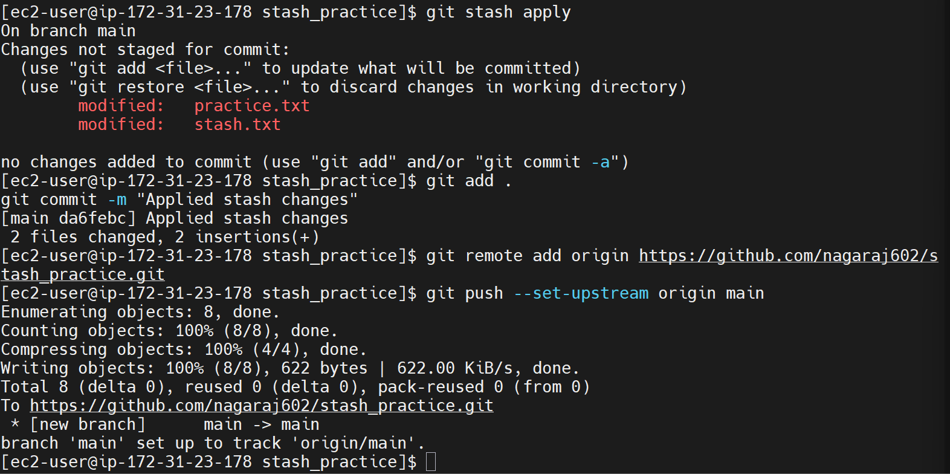

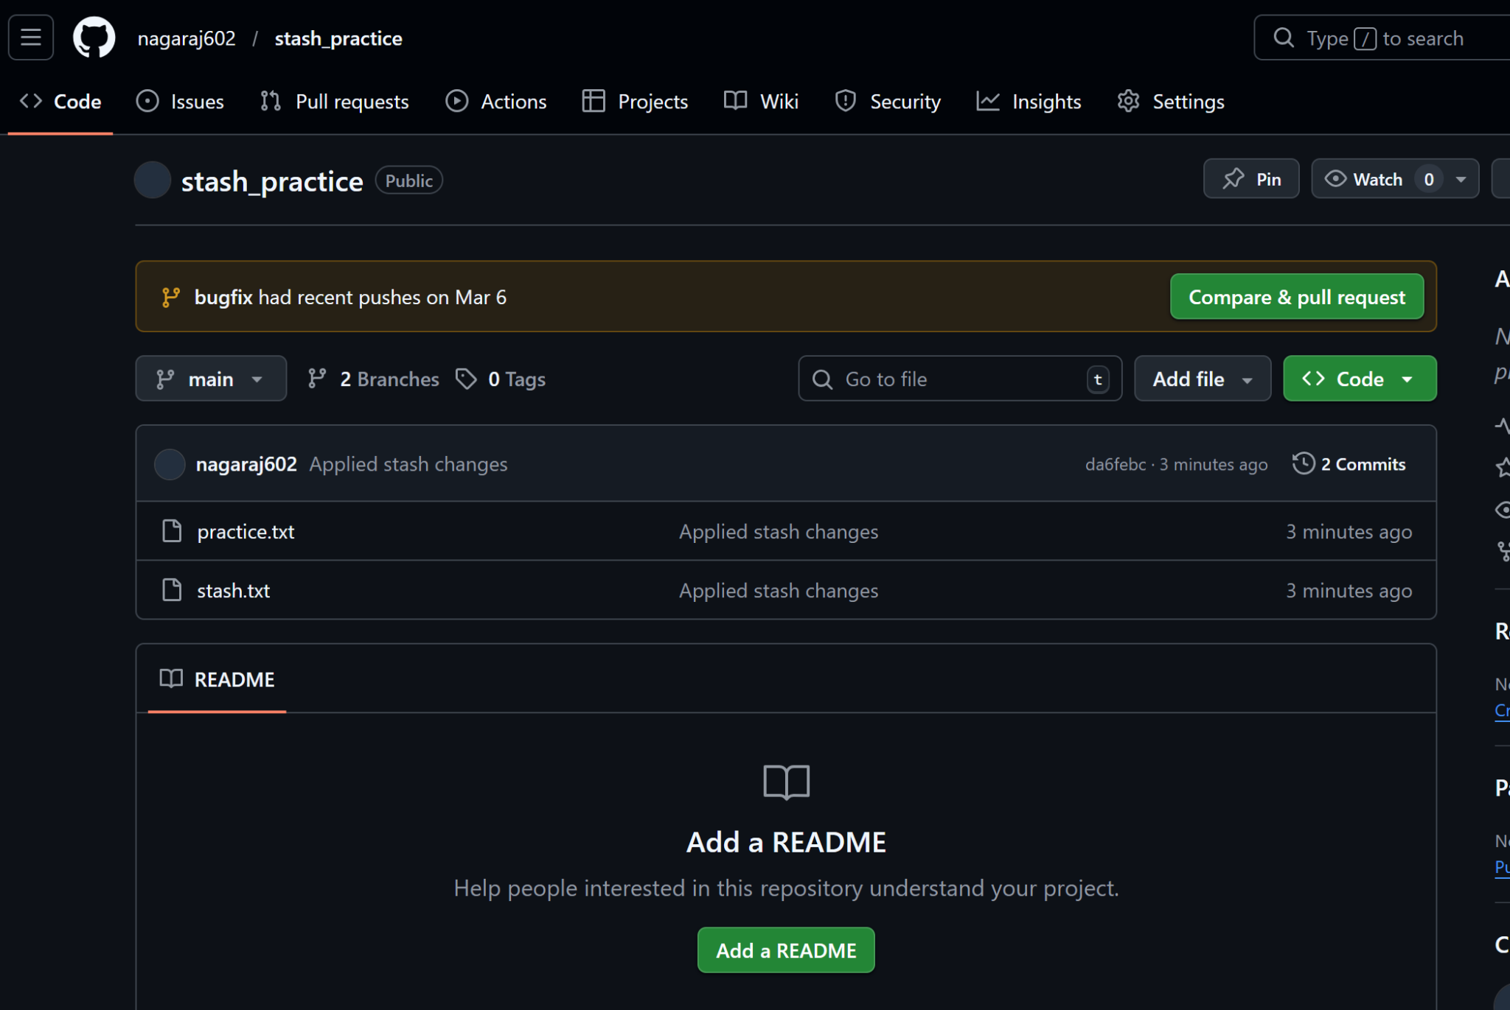

- Task4: Cherry-pick Practice
- Create a repo cherrypick_demo.
- Create a branch featureA and make 3 commits.
- Switch to main and cherry-pick only the 2nd commit from featureA.
- Verify using git log that only that commit was added.
- Push to GitHub and share screenshots of logs before & after cherry-pick.
Ans:
→ mkdir cherrypick_demo
→ cd cherrypick_demo
→ git init
→ echo "Initial file" > app.txt
→ git add .
→ git commit -m "Initial commit"

→ git checkout -b featureA
→ echo "Feature A - change 1" >> app.txt
→ git add .
→ git commit -m "FeatureA commit 1"

→ echo "Feature A - change 2" >> app.txt
→ git add .
→ git commit -m "FeatureA commit 2"

→ echo "Feature A - change 3" >> app.txt
→ git add .
→ git commit -m "FeatureA commit 3"

→ git log --oneline

45800c4 (HEAD -> featureA) FeatureA commit 3
8740090 FeatureA commit 2
821c584 FeatureA commit 1
c8a96b2 (main) Initial commit

→ git checkout main
→ git cherry-pick 8740090
It shows conflict:

Auto-merging app.txt
CONFLICT (content): Merge conflict in app.txt
error: could not apply 8740090... FeatureA commit 2
hint: After resolving the conflicts, mark them with
hint: "git add/rm <pathspec>", then run
hint: "git cherry-pick --continue".
hint: You can instead skip this commit with "git cherry-pick --skip".
hint: To abort and get back to the state before "git cherry-pick",
hint: run "git cherry-pick --abort".
hint: Disable this message with "git config advice.mergeConflict false"
[ec2-user@ip-172-31-23-178 cherrypick_demo]$ vi app.txt
[ec2-user@ip-172-31-23-178 cherrypick_demo]$ git cherry-pick 8740090
error: Cherry-picking is not possible because you have unmerged files.
hint: Fix them up in the work tree, and then use 'git add/rm <file>'
hint: as appropriate to mark resolution and make a commit.
fatal: cherry-pick failed

→ vi app.txt

Initial file
<<<<<<< HEAD
=======
Feature A - change 1
Feature A - change 2
>>>>>>> 8740090

The conflict is because we are cherry picking the 2nd commit, but the 2nd commit depends on the 1st commit. So git cannot decide on merging. So conflict occurred. So we remove the first commit and the 3rd commit to keep only the 2nd commit.

→ vi app.txt

Initial file
Feature A - change 2

:wq

→ git add app.txt
→ git cherry-pick --continue

Added the line in the bottom of the file: "Cherry-pick conflict resolved"

:wq
→ git log --oneline
[ec2-user@ip-172-31-23-178 cherrypick_demo]$ git log --oneline
9b0a9d5 (HEAD -> main) FeatureA commit 2
c8a96b2 Initial commit

→ git remote add origin https://github.com/nagaraj602/cherrypick_demo.git
→ git push --set-upstream origin main
→ git push --set-upstream origin featureA
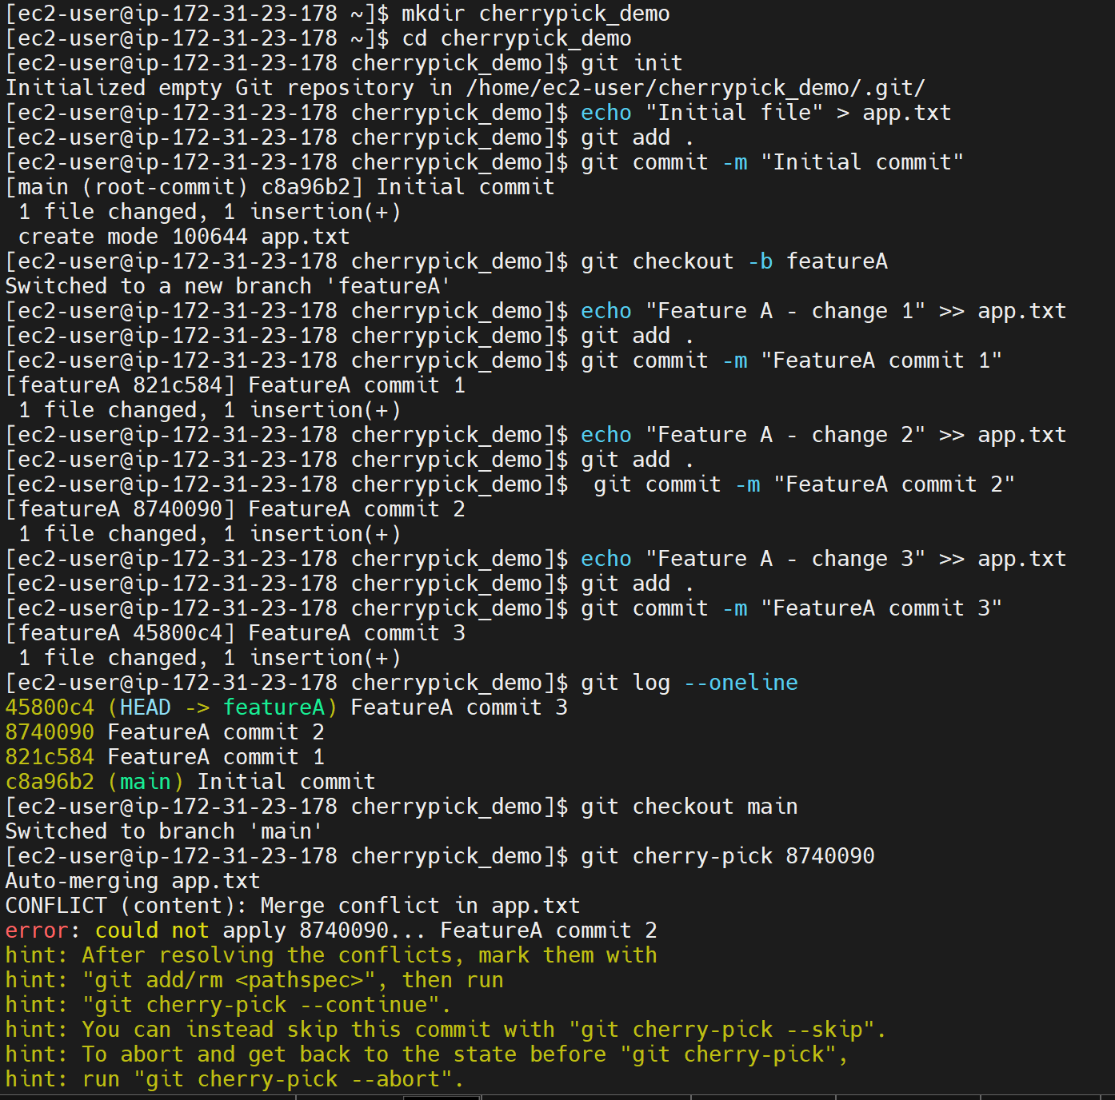

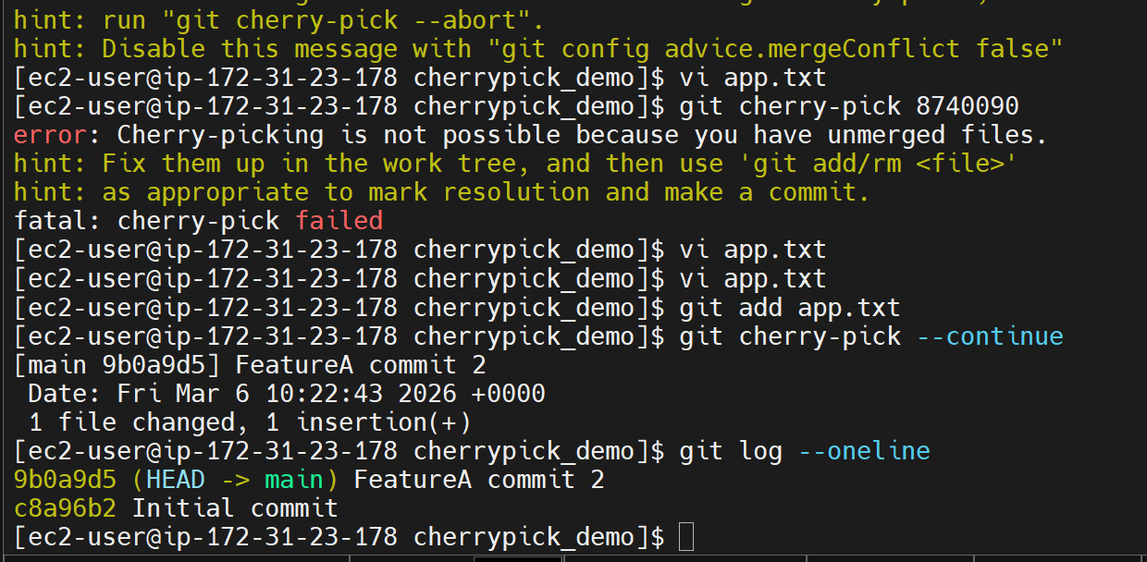

- Task5: Rebase Scenario
- Create a repo rebase_practice.
- Create branches main and feature/db.
- Add a few commits in both branches.
- Rebase feature/db on top of main.
- Resolve any conflicts and complete the rebase.
- Push both branches and share git log --graph --oneline --all.
Ans:
→ mkdir rebase_practice
→ cd rebase_practice
→ git init
→ echo "Initial code" > app.txt
→ git add .
→ git commit -m "Initial commit"

→ git checkout -b feature/db
→ echo "DB connection logic" >> app.txt
→ git add .
→ git commit -m "Add DB connection logic"

→ echo "DB query logic" >> app.txt
→ git add .
→ git commit -m "Add DB query logic"

→ git checkout main
→ echo "Main branch update" >> app.txt
→ git add .
→ git commit -m "Main branch update"

→ git checkout feature/db
→ git rebase main

Conflict occurred:
Auto-merging app.txt
CONFLICT (content): Merge conflict in app.txt
error: could not apply ee11c94... Add DB connection logic
hint: Resolve all conflicts manually, mark them as resolved with
hint: "git add/rm <conflicted_files>", then run "git rebase --continue".
hint: You can instead skip this commit: run "git rebase --skip".
hint: To abort and get back to the state before "git rebase", run "git rebase --abort".
hint: Disable this message with "git config advice.mergeConflict false"
Could not apply ee11c94... Add DB connection logic

→ cat app.txt
Initial code
<<<<<<< HEAD
Main branch update
=======
DB connection logic
>>>>>>> ee11c94 (Add DB connection logic)

→vi app.txt
Remove the conflict marker
→ cat app.txt
[ec2-user@ip-172-31-23-178 rebase_practice]$ cat app.txt
Initial code
Main branch update
DB connection logic

→ git add app.txt
→ git rebase --continue

Go to bottom of the line >> add "Conflict cleared"

:wq

Now rebase continue command shows as:
[ec2-user@ip-172-31-23-178 rebase_practice]$ git rebase --continue
[detached HEAD 7e479cf] Add DB connection logic
1 file changed, 1 insertion(+)
Successfully rebased and updated refs/heads/feature/db.

→ git log --graph --oneline --all
* 6aa54d8 (HEAD -> feature/db, origin/feature/db) Add DB query logic
* 7e479cf Add DB connection logic
* 31cc795 (origin/main, main) Main branch update
* 5c1ce49 Initial commit

→ git remote add origin https://github.com/nagaraj602/rebase_practice.git
→ git push --set-upstream origin main
→ git push --set-upstream origin feature/db

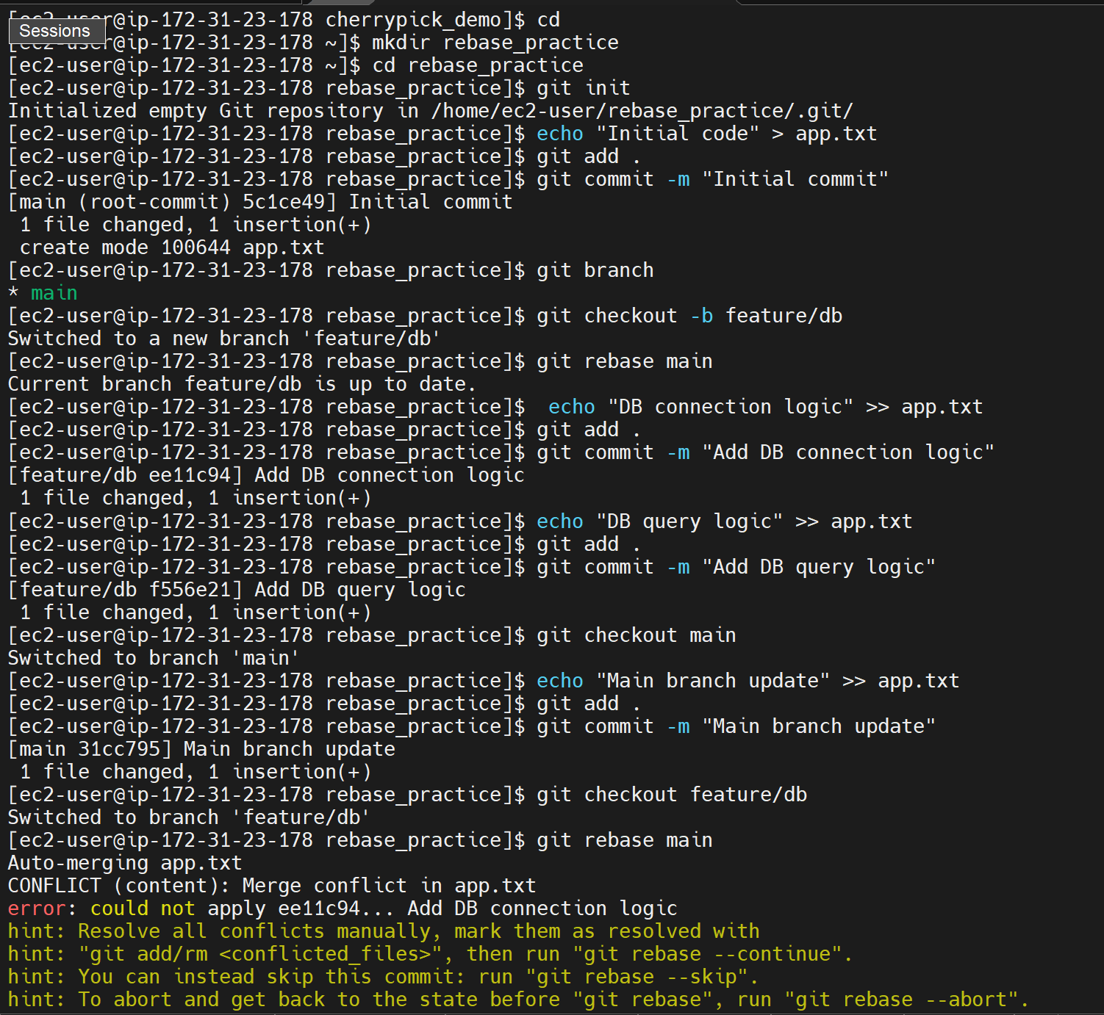

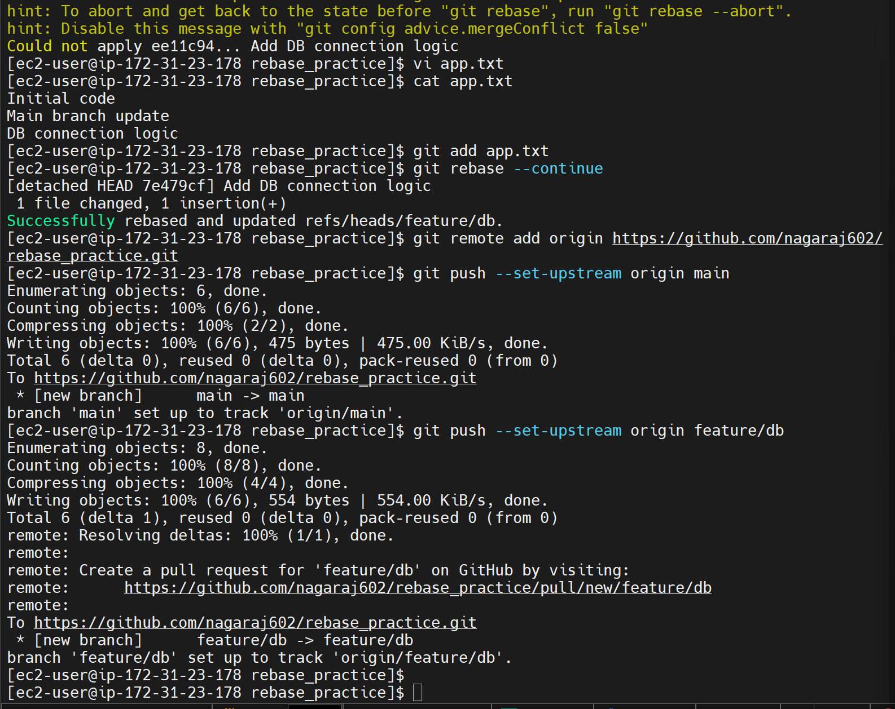

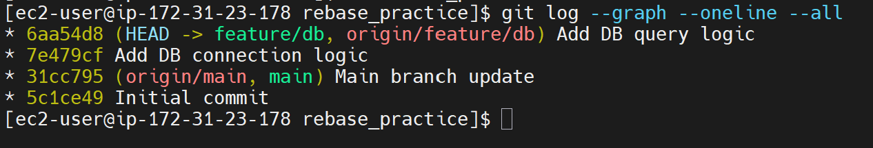
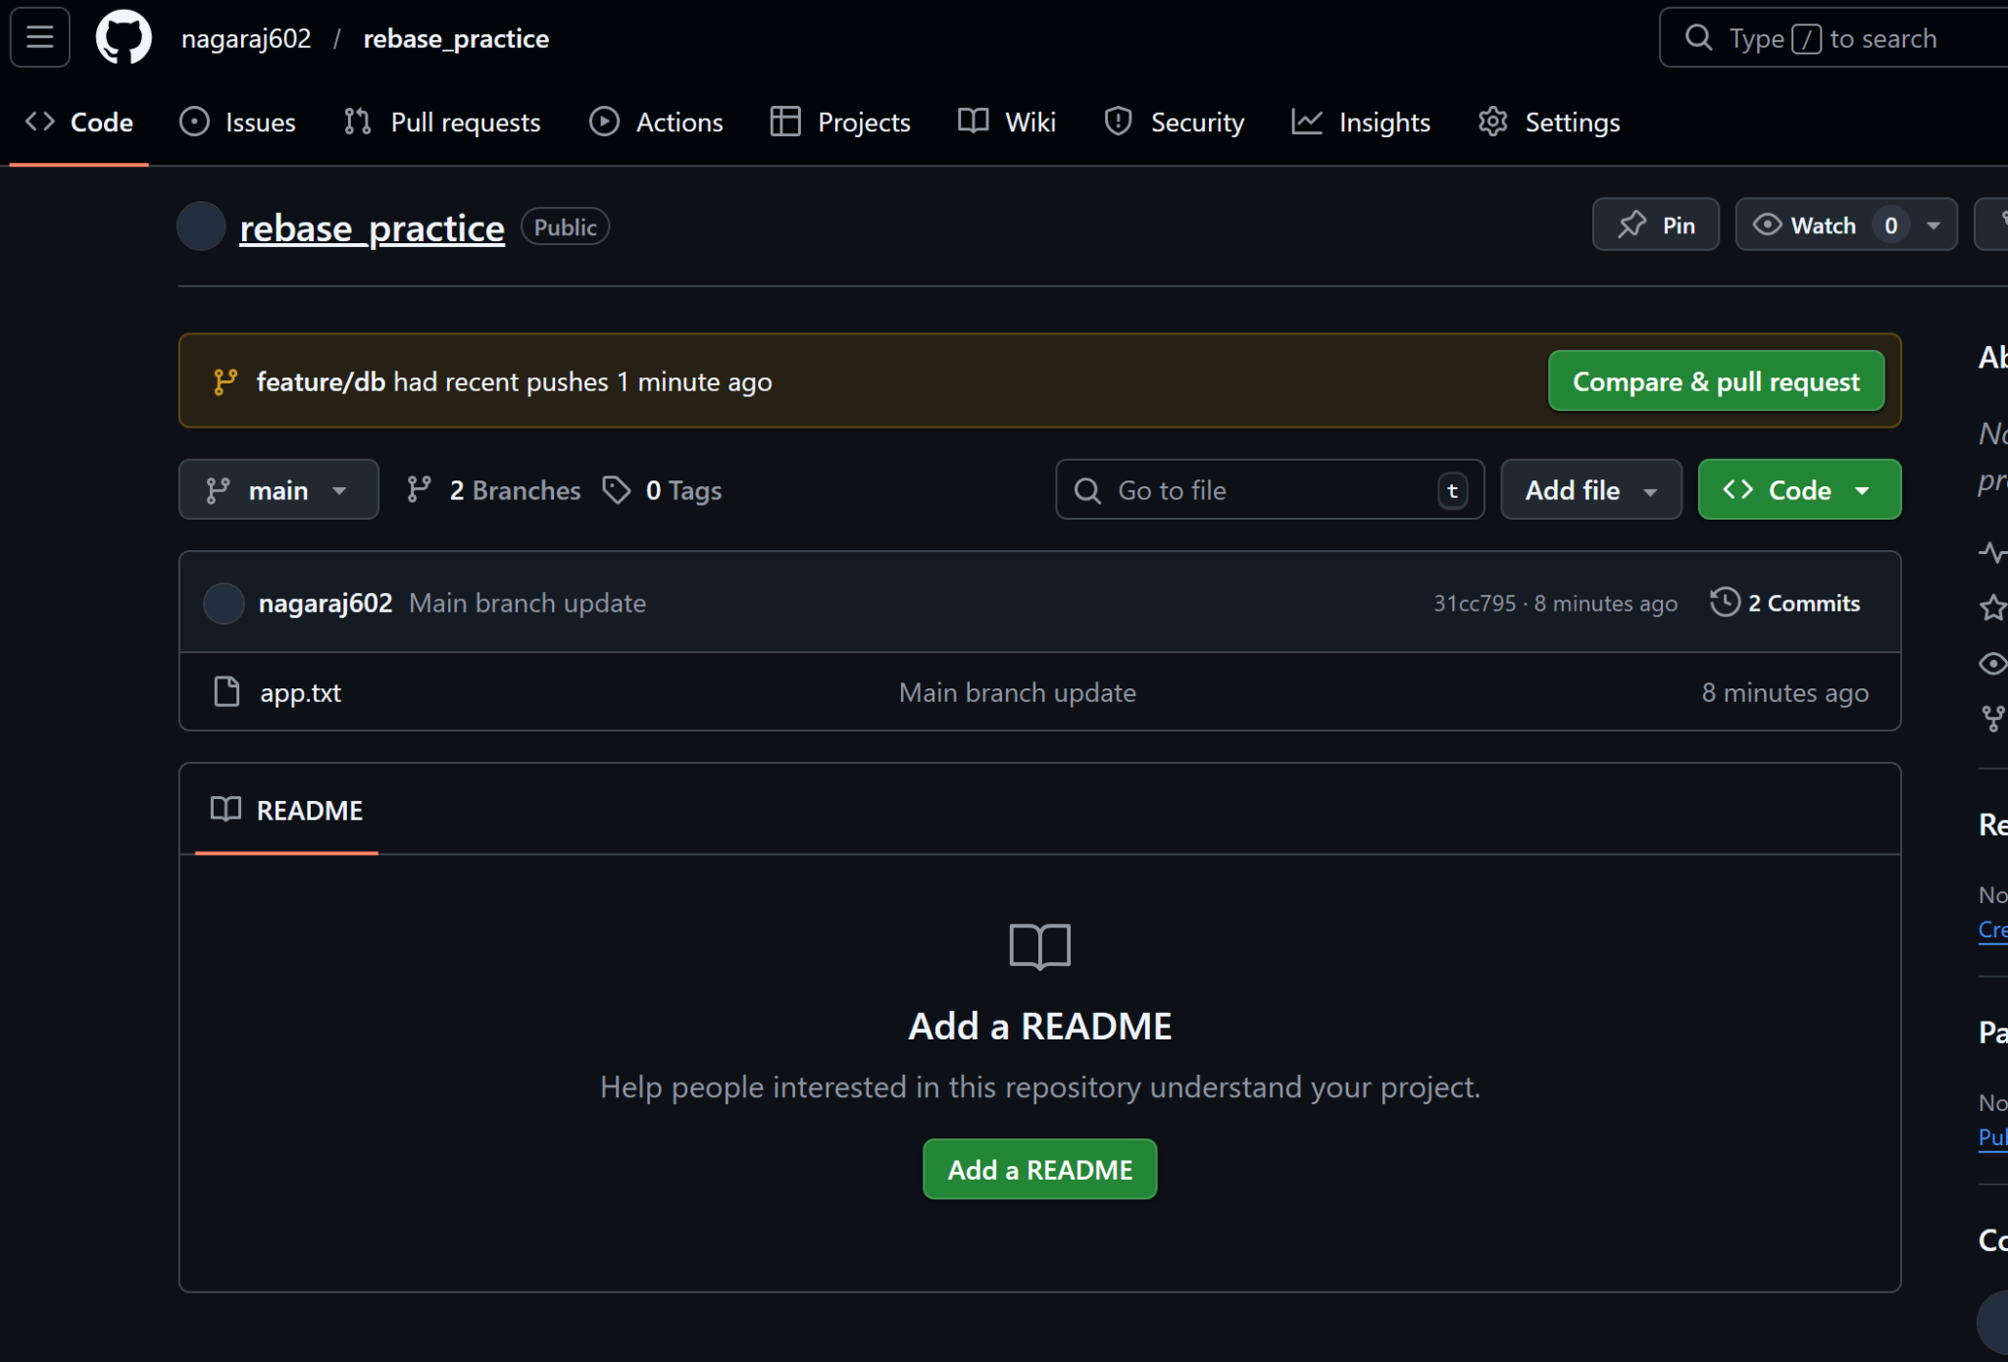

- Task6: Tagging & Release
- Create a repo release_versioning.
- Make 3 commits (v1 feature, v2 feature, v3 feature).
- Tag each commit as v1.0, v2.0, v3.0.
- Push all tags to GitHub.
- Share output of git tag -l and screenshot from GitHub showing releases.
Ans:
→ mkdir release_versioning
→ cd release_versioning
→ git init
→ touch app.txt
→ echo "Version 1 feature" >> app.txt
→ git add .
→ git commit -m "v1 feature"
→ git tag v1.0

→ echo "Version 2 feature" >> app.txt
→ git add .
→ git commit -m "v2 feature"
→ git tag v2.0

→ echo "Version 3 feature" >> app.txt
→ git add .
→ git commit -m "v3 feature"
→ git tag v3.0
( OR) [instead of adding tag after each commit, we can list commits using git log –oneline and then add tag for required commit hash.
→ git log –oneline
1e0c222 (HEAD -> main, origin/main) v3 feature
debe2d8 v2 feature
0adb7b2 v1 feature

→ git tag v1.0 0adb7b2
→ git tag v2.0 debe2d8
→ git tag v3.0 1e0c222
]

List all the tags:
→ git tag -l
v1.0
v2.0
v3.0

→ git remote add origin https://github.com/nagaraj602/release_versioning.git
→ git push --set-upstream origin main
→ git push origin --tags

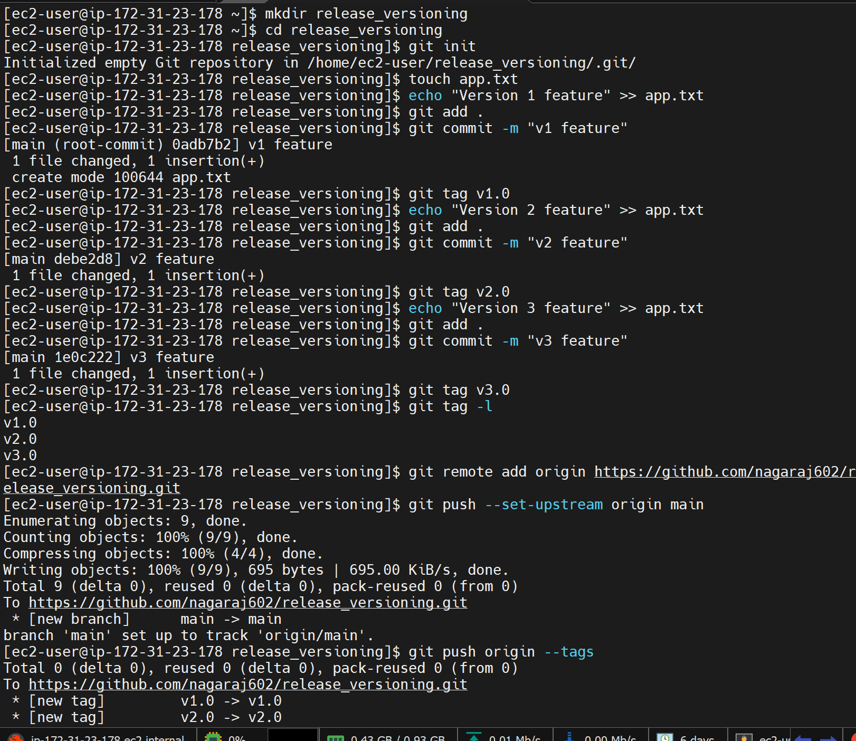

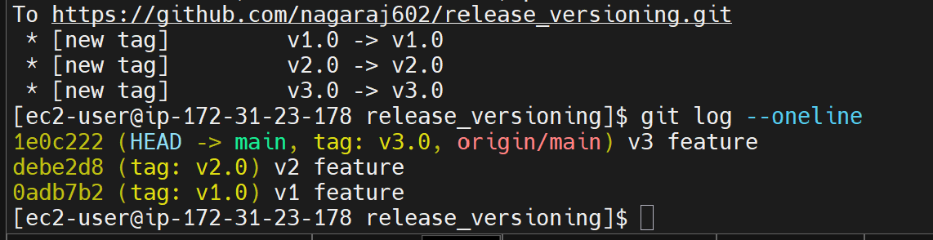
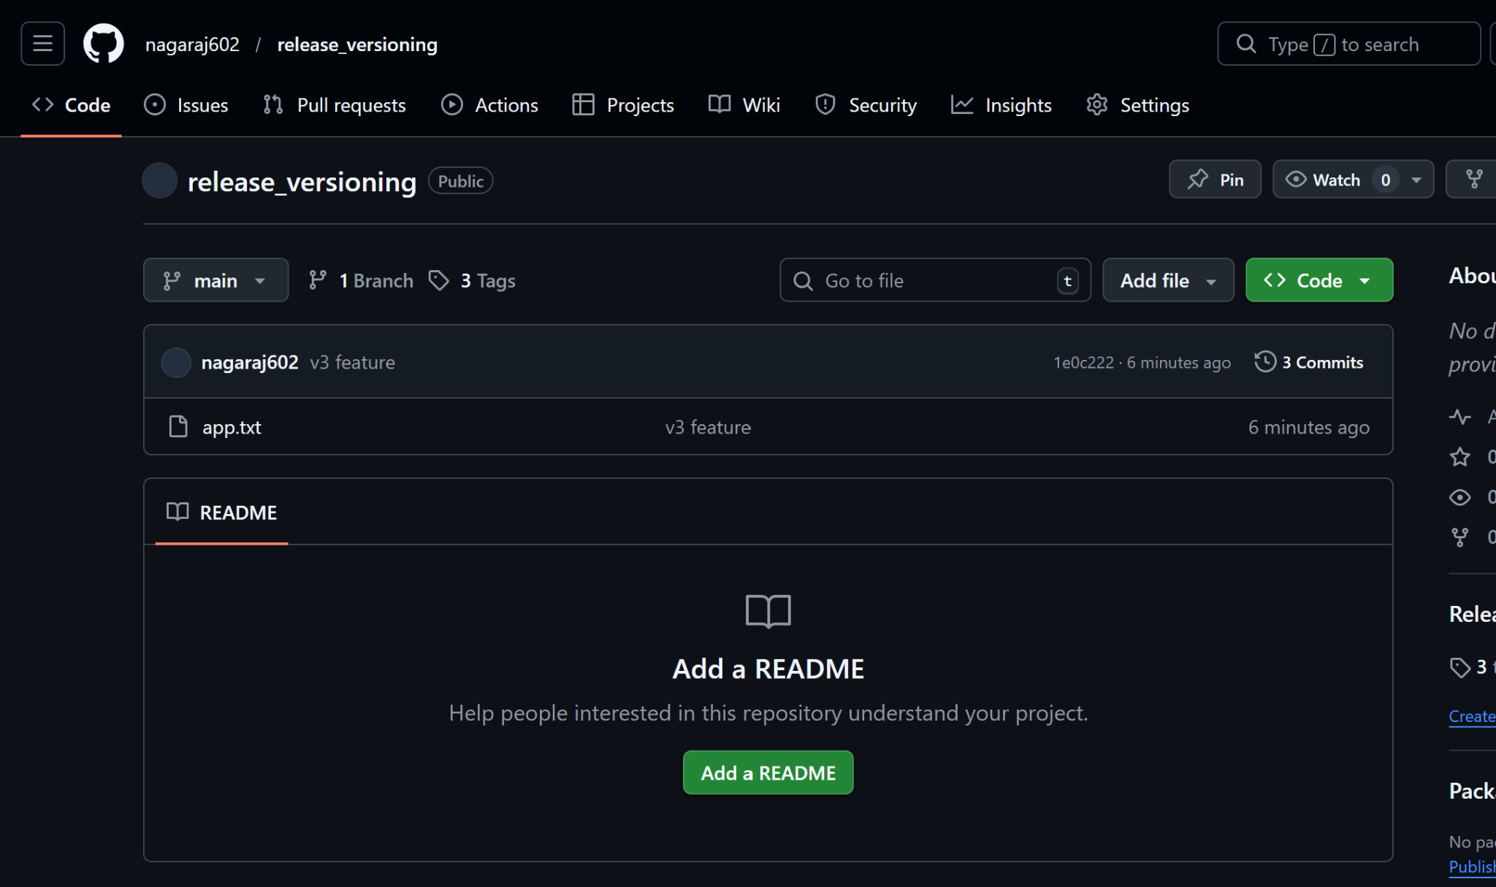

- Task7: Git Collaboration Simulation
- Create a new repo on GitHub and clone it locally.
- Create a branch feature/api.
- Make some commits, push to GitHub, and open a Pull Request (PR).
- Merge the PR using GitHub UI.
- Pull changes back to your local repo and verify.
- Share link to the PR and output of git branch -a.
Ans:
→ Created a new repo in Github: "git_collaboration_demo" with the README.md file.
→ Cloned the repo to local machine
→ git clone https://github.com/nagaraj602/git_collaboration_demo.git
→ cd git_collaboration_demo
→ git checkout -b feature/api
→ echo "API logic added" > api.txt
→ git add .
→ git commit -m "Added API feature"
→ git push -u origin feature/api

Now go to github and it will show "Compare & Pull request" If not shown, we can create pull request.

Title: Added API feature
Description: Added initial API logic

→ Create Pull Request
→ If there is no conflict, then it gives option to "merge pull request"
→ Click on "Merge Pull request"
→ Add the commit message "Merge pull request #1 from nagaraj602/feature/api"
→ Click "Confirm Merge"

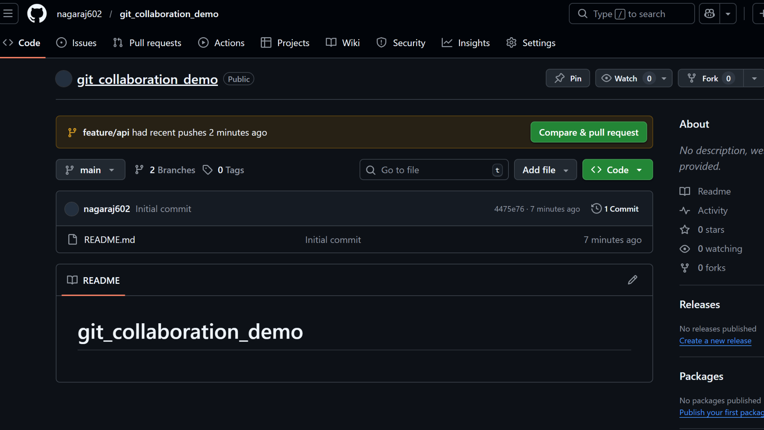

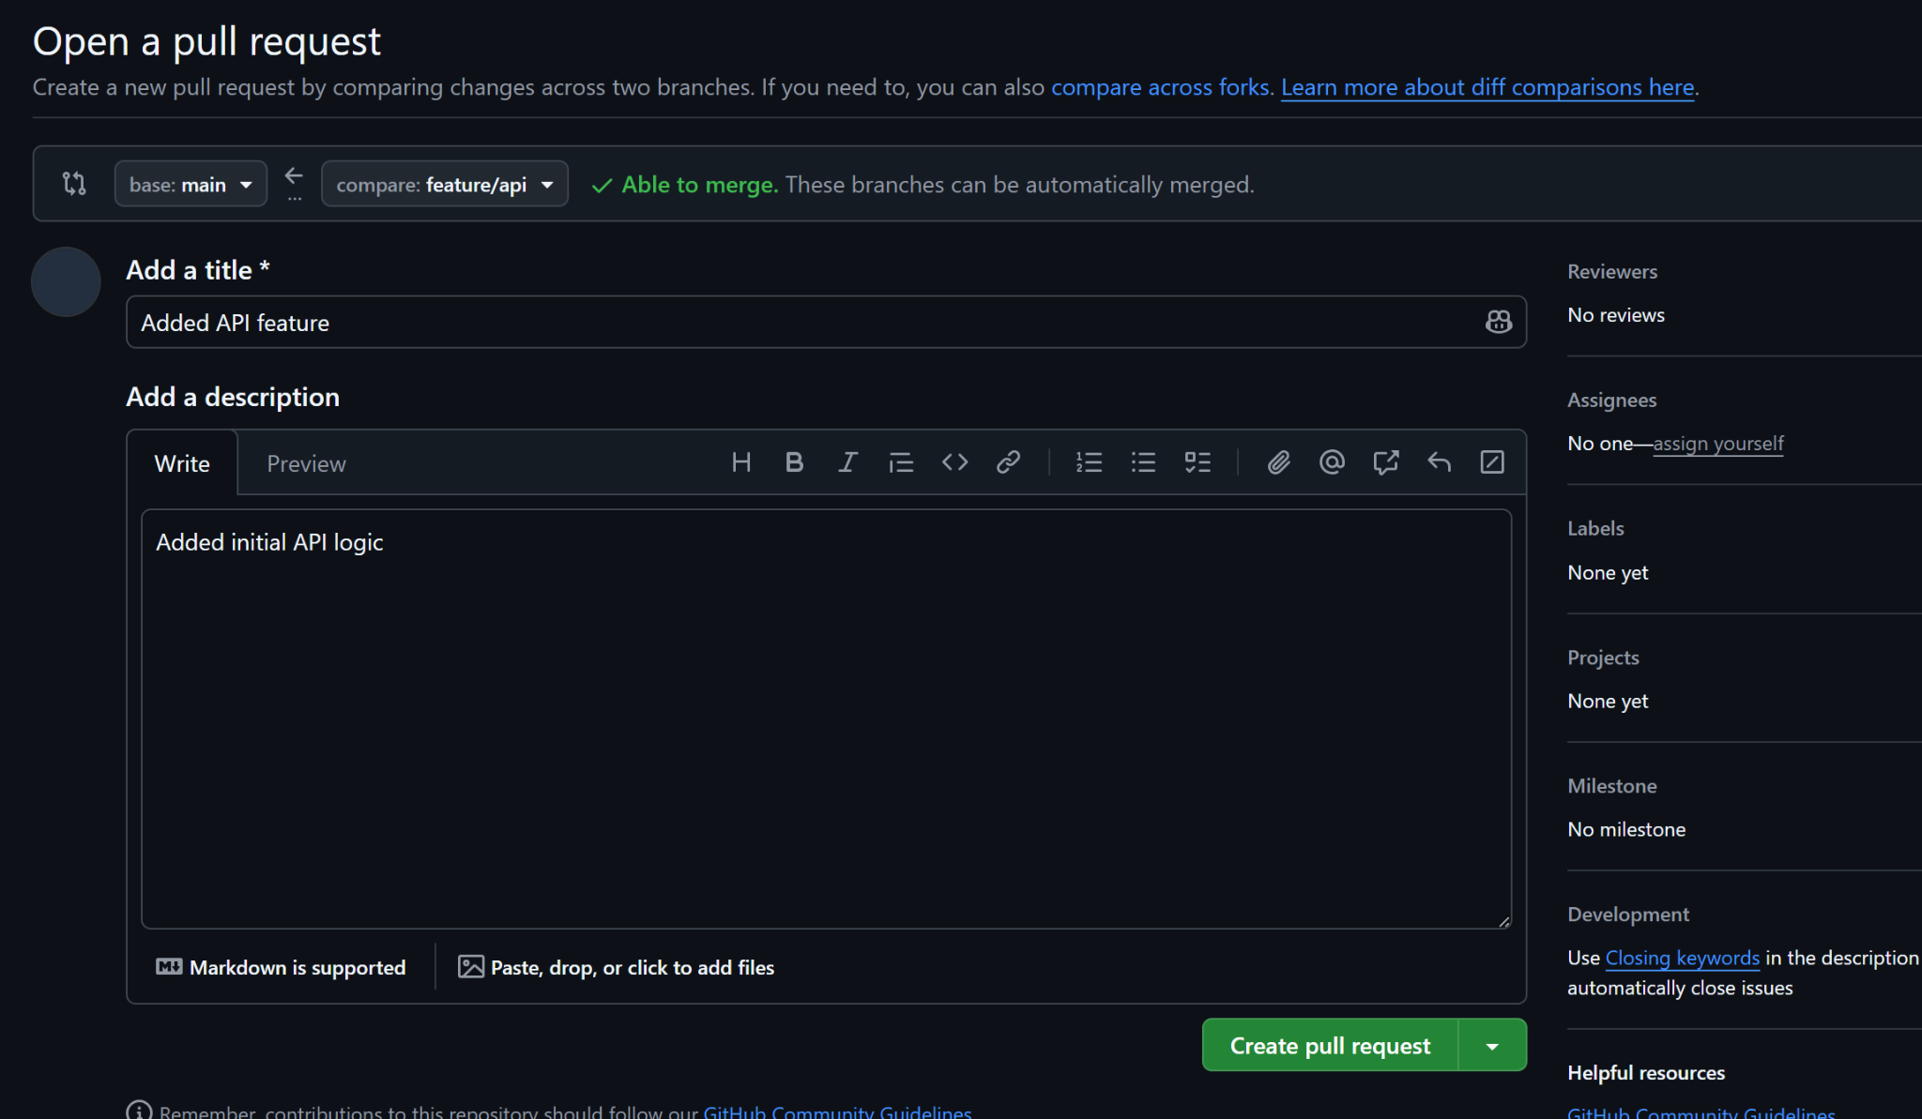

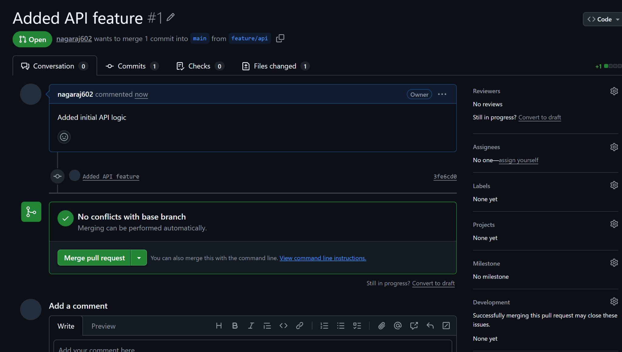
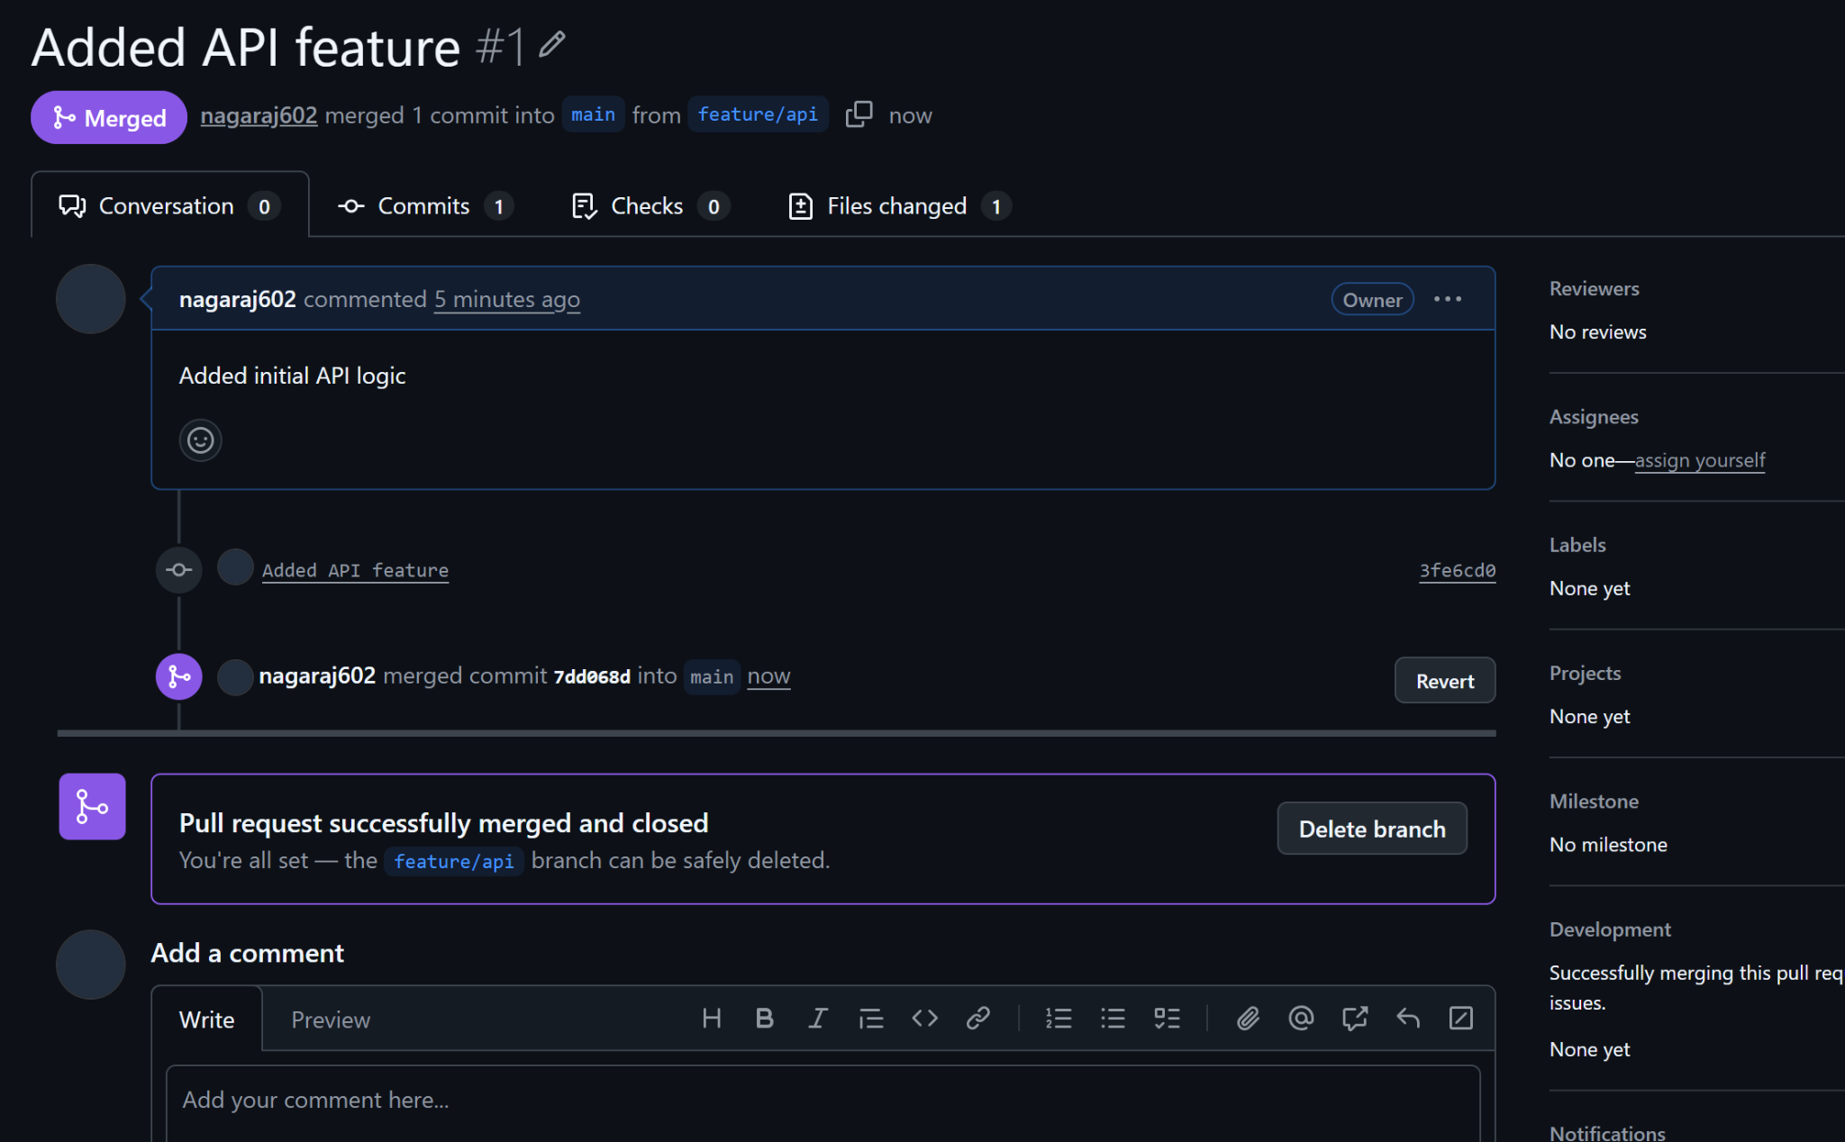

- Create Organization in github and create a repo in it. Invite other members and create a branch for them and let each member upload their shell script assignment script to their respective branch.
Ans:
Create Organization: Click on your profile (Or click on Plus symbol which we use to create new repo, there it has new organization option) >> organization >> New organization >> Select Plan for organization: Free >> Enter Organization name: nagaraj-org >> contact email >> set as attach with personal account >> solve captcha and accept the terms and condition >> Invite the member by adding member username or email address or Full name >> It creates organization >> Invite other members if needed.
Now create new repo: shell_script >> create readme.md file >> Create branches for 3 members:
nagaraj
kumar
nithin
>> Go to your git >> clone the repo >>
git clone https://github.com/nagaraj-Org/shell_scripts.git >> git branch >> it shows only the main branch >> git clone won't add all the branches to the working directory, it adds to the remote tracking. So if you use→ git branch -r or git branch -a → then it shows the remote tracking branches >> Now use: git switch nagaraj or git checkout nagaraj >> this brings your branch to your working directory. >> Now add all the shell script files to your working directory >> add it to staging area using:
git add .
>> commit the changes:
git commit -m "Added Script files"
>> push the commit to remote repo from your nagaraj branch using:
git push --set-upstream origin nagaraj

